VALE OF THE RED HORSE HEALTH CARE CENTRES

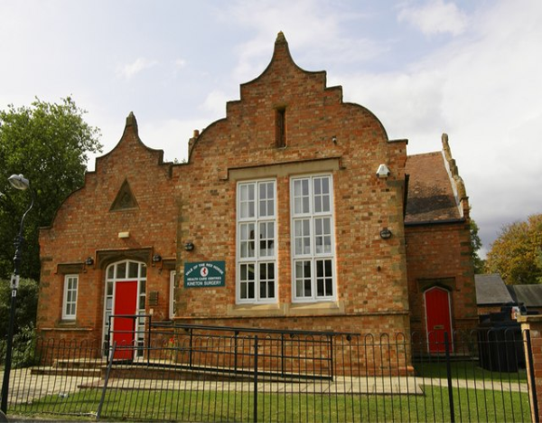

Statement of Purpose

Statement of Purpose

The name and address of the registered provider is Dr Woodward & Partners, Vale of The Red Horse Health Care Centres, Old School, Market Square, Kineton, CV35 0LP, 01926 640471

CQC Registered Managers: Dr Jenny Layton-Henry
Partners: Dr Jenny Layton-Henry, Dr Raj Kanwar
Dr Catherine Spencer Hammon, Dr Carly Williams, Dr Rosalind Norton &
Dr Amit Chauhan
Practice Manager: Mrs Lesley Source
Assistant / IT Manager: Ben Evans

The surgery main site is located in the village of Kineton, South Warwickshire with a purpose built branch surgery based in Tysoe. Both surgeries have onsite parking. The Vale of The Red Horse Health Care Centres is also a Training Practice.
Under the Health and Social Care Act 2008 (The Care Quality Commission (Registration) Regulations 2009 Part 4), the registering body (Vale of The Red Horse health Care Centres) are required to provide to the Care Quality Commission a statement of purpose.

Our Aims and Objectives
- We aim to ensure high quality, effective services in a safe environment
- To be a patient centred organisation
- To provide monitored, audited and continually improving healthcare services
- To provide healthcare which is available to the whole population and create a partnership between patient and clinicians which ensures mutual respect, care, continuous learning and training.
- The provision of accessible healthcare which is proactive to healthcare changes, efficiency and innovation and development.
- To continue to improve Clinical Governance and Evidence Based Medicine
- To continue to improve our Clinical and Non-clinical risk management strategies
- To continue to review and improve the practice environment and capacity
- To improve vigilance for unforeseen emergencies
- To optimise performance against key targets and core standards
- To meet key targets
- To offer NHS Health Checks
- To improve communication between the surgery and the patients
- To retain and develop a highly motivated and appropriately skilled workforce
- To enhance performance of the workforce by providing staff member Personal Development Sessions
- To guide the employees in accordance with the Equalities Scheme
- To ensure all staff understand the Information Governance System
- To ensure a robust Information Technology strategy to support the Vale of The Red Horse Health Care Centres

The registered activities and service types have been agreed by the Practice Manager and partners in accordance with CQC guidance. Services are described under registered activity and Service Type.

The regulated activities under CQC (The services provided by the Vale of The Red Horse Health Care Centres) are:
- Routine medical checks and general medical services
NHS relevant prescriptions and medications or a private prescription can be issued.
- Immunisations, e.g. childhood immunisations
- Foreign travel and immunisation
- Weight loss and Dietician clinic lifestyle management - Executive & employee medicals – Our GP’s are able to carry out medical report and review.
- Assessment of employees returning to work after illness
- Smoking Cessation - Any patient who is a smoker and ready to stop smoking will be seen by one of our advisers for an assessment at either Kineton/Tysoe Surgeries.
- Respiratory clinic – The Vale of The Red Horse Health Care Centres have the facility for spirometry / lung function testing.
- Diabetic clinic - Vale of The Red Horse Health Care Centres operates a diabetes clinic each week to provide ongoing care for our diabetic patients and run by trained nurses and supervised by two senior GP Partners.
- Family planning clinic – Our family planning clinic is run by our Nurse Practitioner.
- Flu vaccination - At Vale of The Red Horse Health Care Centres we offer 'at risk' groups the flu vaccine at a certain time each year to protect you against the flu virus.
- Phlebotomy - Vale of The Red Horse Health Care Centres offers a variety of appointment times for blood tests
- Midwifery - The community midwives hold their own clinics at Vale of The Red Horse Health Care Centres for patients at Vale of The Red Horse Health Care Centres. They supervise antenatal care, undertake deliveries in hospital and at home where appropriate.
- Minor surgery - We offer a number of minor operations/surgeries for dermatology related concerns. The minor operations are held with Dr Spencer-Hammon.
- Physiotherapy - NHS Physiotherapy is available at Vale of The Red Horse Health Care Centres.
- Ear syringing and audiology Vale of The Red Horse Health Care Centres has facilities for audiology and ear syringing.
- Well person checks – These can be carried out with any practice nurse.
- NHS Health Checks – For eligible patients. Our NHS Health Checks are carried out by our Health Care Assistant Karen Glover.
- ECG monitoring - At Vale of The Red Horse Health Care Centres, we are proud to be one of the very few GP surgeries in the area which offer 24 hour ECG Screening and Monitoring, as we have a fully functioning ECG machine in the practice, and this is a service which would usually have to be provided by a hospital or minor injuries unit.
- Cervical screening - At Vale of The Red Horse Health Care Centres, our nurses are qualified to carry out cervical screening and tests in the form of cervical smears.
- Over 75’s Enhanced Clinical Reviews – Our reviews for patients aged over 75 are completed by our Lead Nurse Yvonne Wallsgrove.

Our practice ethos is to strive towards a partnership between patients and health professionals based on the following key facets:

Mutual Respect
We endeavour to treat all our patients with dignity, respect and honesty. Everyone at Vale of The Red Horse Health Care Centres is committed to deliver an excellent service. We ask all patients to highlight any discrepancies and to offer the same commitment in return.

‘Holistic’ Care
We treat ‘patients’ and illnesses. This means that we are equally interested in the physical, psychological and social aspects of your individual care.

Continuity of Care and the ‘Therapeutic relationship’
Building and maintaining a strong relationship between doctors, health professionals, and patients is essential to the way we work. This is especially so in the management of ongoing problems or long-term illness. In these circumstances we would encourage you to continue seeing the same health professional and wherever possible we will facilitate this through our appointments system. However, if you have a new problem, the doctor or nurse that you normally see is not available, or you would like to see someone else then we would encourage you to see any of the doctors or nurses at the practice.

Learning and Training
We have been a training practice for many years and are committed to the training of doctors and nurses all of whom are closely supervised. We believe in “life-long learning” and all the health professionals here and administrative staff have annual appraisals where learning and development needs are identified. We also undertake an annual Practice Development Plan to ensure we constantly seek to provide safe effective care for patients and a positive place to work for staff.

We also recognise the benefit of supported learning for our patients and families in enhancing your ability to manage and deal with both ‘self-limiting’ and long-term illnesses

‘The right treatment at the right time in the right place’

LS
6/2/2013
Amended 13th July 2015
Updated July 2016

